Game Menus

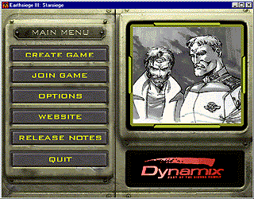

Main Menu
Top level game commands for starting or joining a game, visiting the Sierra ES3 website and control options are available from this menu.

Create Game (button)
Join Game (button)
Options (button)
Website (button)
Release Notes (button)
Quit (button)

Website
Clicking this button will launch your Internet browser and take you to Sierra's Official Earthsiege 3 Website.

Release Notes:
If you are reading this, you have obviously figured this one out.

Options:
This will take you to the game options screen. There are two sections to the menu, a screen settings section, and several sliders which control the graphics detail settings of the game.

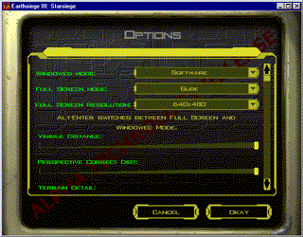

Options Screen Drop-Down Menus:
Windowed Mode
Full Screen Mode
Full Screen Resolution

Windowed Mode:
The only option available at this time is software. Voodoo Rush windowed mode (3D Hardware accelerated) is not supported in this initial tech release. When a driver is available we will post it on our web site. Though the game initially starts in a window and can be run entirely in this mode, we recommend you switch to full-screen mode by pressing alt-enter for best game performance in the simulation.

Full Screen Mode:
If you have a 3DFX chipset-based 3D accelerator, you can select Glide as the display device on this menu. If the correct version Glide driver and compatible hardware are not detected on your machine, “Software” will be the only choice available on this menu.

Full Screen Resolution:
This will allow you to select screen resolution of the game based on the full screen mode you have selected. If you have a slower machine (Pentium 133 or less) and are using software for the full screen mode you will probably want to decrease the full screen resolution below 640X480 for best performance.

Options Menu Sliders:
Below the drop down menus is a scrollable list of sliders that allow you to change the graphics settings of the game to improve performance. Moving the slider to the left by left-clicking with and dragging with your mouse will decrease the graphical detail of the game and enhance performance. The initial settings are automatically determined the first time you run the game. If you wish to return to default settings after you have changed the preferences, you must delete the file defaultPrefsCfg.cs. The next time the game is run, the auto-configuration program will run again.

Depending on your processor and whether you are running under software or using a 3D hardware accelerator, the various slider bars will affect performance to a greater or lesser degree. Turning down the detail on shadows, decreasing the visibility distance, and lowering the terrain detail will probably show the greatest improvements in performance.

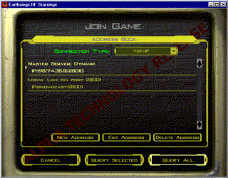

Join Game (Address Book)
This is the option you will probably want to use most often, especially if your machine is near the lower end of the supported hardware spectrum. From here you can search for other Earthsiege players running game servers over the internet or a LAN to connect to.

There are several parts to this screen:
Address Book Region
Device (Drop Down Menu)
Servers List (scrolling list)
New (button)
Edit (Button)
Delete (button)
Join Menu Region
Query Selected (button)
Query All (button)
Cancel (button)

Address Book Region
The address book is where you can keep track of all the servers you find on the internet or your local network. This provides a convenient way of locating people you connect with frequently.

Device Drop Down Menus
The Device Drop Down menu is activated by left-clicking on the down arrow with the mouse. This will indicate the type of connection you use to play a multi-player game. The only choice supported in the tech demo is IP.

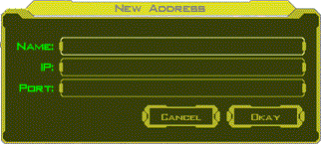

New Button
This brings up a new address dialog box allowing you to enter a new server Name (label), and address so that you can easily find it again. You must type in the server label (name), the IP address, and the network port number.

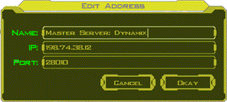

Edit Button.
This button allows you to change the name and internet address of a server. You may want to do this if you are using a LAN (or connecting to someone who is) where the IP addresses can change each time you start a game or to change the port number if the default one is unavailable.

Delete Button.
The Delete button will remove the currently selected entry from your address book.

The first time you try to join a game you will probably see only two entries. One of the entries will be:

Dynamix: Master Server
IP: 198.74.38.12:28010

This "master server" is special type acting as clearing house for game servers people have registered with us. Its kind of grand central station to find other Earthsiege games over the internet. All Earthsiege servers on the internet will announce themselves to the Dynamix Master Server when they start up. For this reason, you may wish to enter a password if you are starting a private game. Otherwise, any Earthsiege players on the internet can enter your game.

The other kind of server you will see on this screen is a normal game server. You can connect directly to this type and play a game. If someone is running a game on your local network you will see something like

Local Lan on Port 27001
UDP:Broadcast:27001

If you have placed other severs in your address book, the will appear here as well. When you want to connect to a server, you must "Query" to check and see if it is available.

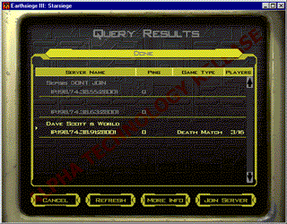

Query Selected button
This will search your network or the internet to find the server currently highlighted in your address book and display it in the Query Results Screen. If you have selected a "master server" here, you will get a list of several servers to choose from. When you have queried a game server, the information for that server will be displayed, along with its game type, ping time, and the maximum number of players the server will accept. Pay close attention to the "Ping Time." You want this number to be as low as possible.

Query all Button
This will check all the servers in your address book to find games. It may take a while, so be patient. This can potentially generate a very long list.
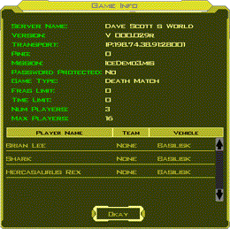

More Info button
This will display the options your host (person who started the game) has selected.

Refresh button
This button will update the status of the game servers in your list and tell you if they are still available or if they are no longer available to connect to.

Join Server Button
The join server button will connect you to the selected server and bring up the player setup menu (See Player Setup Menu below).

Cancel Button
This will return you to the previous menu.

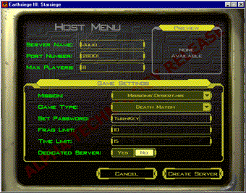

Create Game (Host Menu)
You will want to select this option to configure a server and/or host a multiplayer game. Generally speaking the person with the fastest machine and best Internet connection should host your game. The host determines the game settings for the multi-player session.

Create Game (Host Menu) components:
Server name (field)
Port Number (field)
Max Players (field)
(Game Settings)
Mission (drop down menu)
Game Type (drop down menu)
Set Password (field)
Frag Limit (field)
Time Limit (field)
Dedicated Server (Yes/No Buttons)
Create Server (Button)
Cancel (Button)

Server Name Field:
Enter the name that will identify your server in this field, e.g., "Rick's server" or "Alpha HQ". The maximum name length is 22 characters.

Port Number Field:
The default port number is 28001. These numbers can be thought of as "channels." If you are running more than one server on your LAN or your local machine, each one should be assigned a unique port number. The game will remember the last port number assigned and numbers can be recorded in your address book so you can easily locate the server again. See the section on "Address Book" below for more information. If you are the only one playing an Earthsiege game on your network, you can leave this alone.

Max Players Field:
This determines the maximum number of players the server will allow in a game. There is no inherent limit in the game code: the speed of your internet connection and power of your computer will determine how many people you can connect with while maintaining good performance. In general, the fewer players connecting to a game server, the better the performance will be. Running a dedicated server will provide the best performance with a larger number of players.

Preview Window:
Displays an image of the currently selected mission environment. This is determined by the scenario selected in the game settings “Mission” field.

Game Settings

Mission Field:
The mission environment for the multiplayer game is selected from this drop down menu. Left-click once on the down arrow at the left side of this field. Then left-click on the mission you wish to select.

Game Type Field:
Only Death Match and Team Play death match are available. Death match games are every man for himself, while team play tallies frags and deaths for your group as a whole. You weapons hurt your teammates in team play, but they will not be selected as a target unless you right click on them with the mouse.

Password Field:
If text is entered in this field, all players joining your game must enter it exactly as you have typed it in order to join the game. Leaving it blank will allow anyone to join your game. The maximum password length is 22 characters.

Frag Limit Field:
Sets the number of frags (enemy kills) required to win a session. When this number is reached, the session will end with the person or team reaching this limit as the winner. If no number is specified the frag tally is continually incremented until the session ends.

Time Limit Field:
The time limit sets the duration of a multi-player session in minutes. When the time limit expires the game will end. The team or person with the most frags at the end of the time limit is declared the winner. If no number is specified, the session is not limited by time.

Note: If neither the frag limit or time limit is specified the game will not end until the Host terminates the session.

Dedicated Server:
To play a network game you must have a server. This is the program that handles the network connections and sends the data to all the players in the game. There are two types of servers:

YES Button (Dedicated server: You can't Play)
If the YES option is checked, your machine will become a "dedicated" Earthsiege Server. A dedicated server is a machine that's dedicated to one purpose in life: handling the network data for an Earthsiege Multi-player game session. Once you have started it, a dedicated will sit on your network or the Internet and wait for people to connect to it. This provides the best possible performance for a network game but you can't PLAY the game on the same machine you are running a dedicated server on: you need a second machine to enter a mission.

NO Button (Non-Dedicated server: You can Play)
This is a machine where the Host (the person who sets up the game) wishes to create the server AND play the game on the same machine. This allows you to handle the networking data and play the game on the same machine, but it places the greatest burden on your computer processor. Most people will play the game on a non-dedicated server.

If you are still confused just click "NO" and move on. It's not the end of the world.

If you just want to join a game that already exists you don't care about any of this. Click the "Cancel" button, go back to the main menu, and select "Join Game."

Create Server Button:
This button will create a server based on the selections currently displayed on the New Game (Host) Menu and launches the server if you have the "dedicated" server YES option checked. If you have a non-dedicated server the next menu you see will be the Player Setup Menu. See below for a description of the player setup menu.

Cancel Button:
This button cancels all choices and returns you to the main menu.

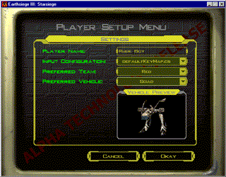

Player Setup Menu.
This is where you enter your pilot name, select your vehicle, and choose your team (if team play has been selected by the host). The following options are available:

Player Name (field)
Input Configuration (drop down menu)
Preferred Team (drop down menu)
Preferred Vehicle (drop down menu)
Vehicle Preview (Window)
Cancel (Button)
Okay (Button)

Player Name Field:
Type your pilot's name in this field. The maximum length is 22 characters.

Input Configuration:
This allows you to choose the keyboard and input device control mappings. Choose the file that suits your preferences and control setup. The default “keyboard_mouse.cs” configuration will do to get most players started. Keymaps for a variety of popular combat games and input devices are available here as well.

Note for the serious gamers: all key assignments, joystick, mouse and other input device functions are completely customizable and can be changed by editing the input configuration files. Please see refer to “Input Mapping Help Text” for instructions on creating a custom keymap to suit your personal tastes. If it was not included with your download it is available at http://www.dynamix.com/es3.

Preferred Team:
If team play has been selected in the Create game (Host) menu, you may choose the color of the team you wish to play for here. If Deathmatch is selected, this option is unavailable. To select your team color, left-click on the down arrow, then left-click on the team color you wish to select. When target another player, the box around their vehicle will appear as the color you select here.

Preferred Vehicle.
Select the Herc type you wish to pilot at this menu. Left-click on the down arrow, and then left-click on the name of the vehicle type you wish to pilot. For a description of the different vehicles and their weapons, you can download the file "vehicles and weapons" from the Earthsiege Website.

Preview Window:
This displays an image of the vehicle you have selected.

Cancel Button:
This will take you back to the previous menu. It will either be the join menu or the Create Game (Host) menu, depending which one you came from.

Okay Button:
This accepts your choices and launches the game.

